The ONLY Beginner Trading Strategy YOU Will Ever Need.

List of Candle patterns for entry reasons
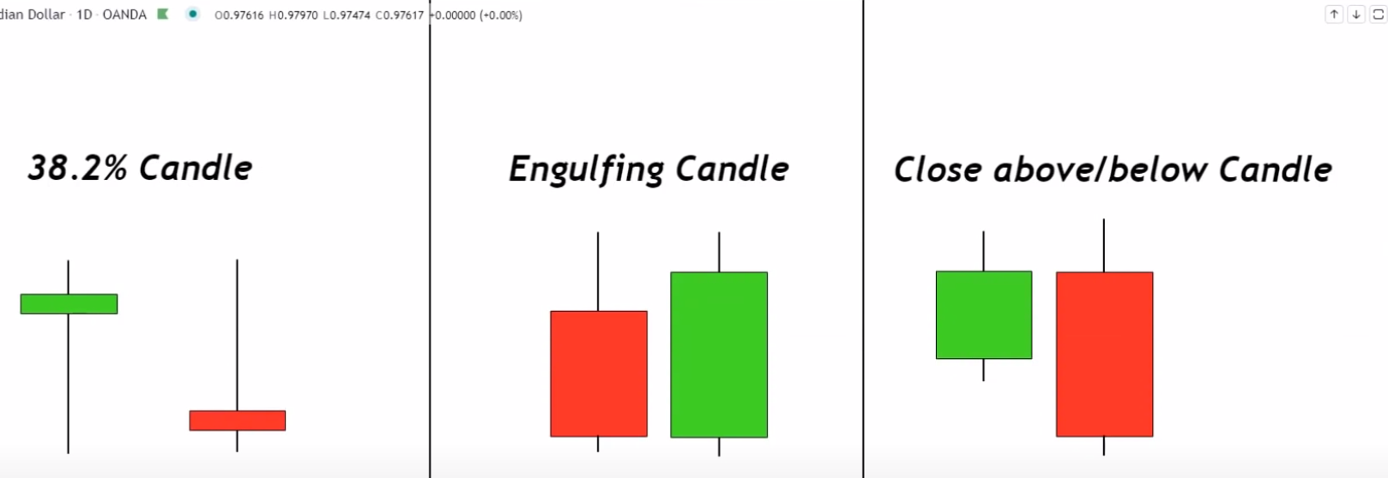
- Double tops and bottoms

- Identify the 38.2% candle pattern in an objective way using a fibonacci retracement from the top of that candle down to the low and as long as the entire body of that candle is below the 38.2% etracement then i know that selling pressure,

- Engulfing candle is a candle that has a larger body than the previous candle and that changes colors. so for a bullish engulfing pattern i need to see that

- The previous candle was red that the next candle is green and that the green candle has a larger body than the previous candle that is a bullish engulfing candle for me.
- The bearish engulfing pattern is the opposite of bullish.

Trading the patterns Bullish version
Conditions.
- We're going to be using the 20 period moving average.
- price must be trading above that 20 period moving average

- Wait on 38.2 percent candle (price) to touch the 20 period moving average and wick off.

Entry rules:

- The close of that 38.2 candle is our entry and then we put stops and targets accordingly.

Bearish version

Entry

- The market is trading below the 20 period moving average.
- Wait for a candle to wick off of that 20-period moving average..

